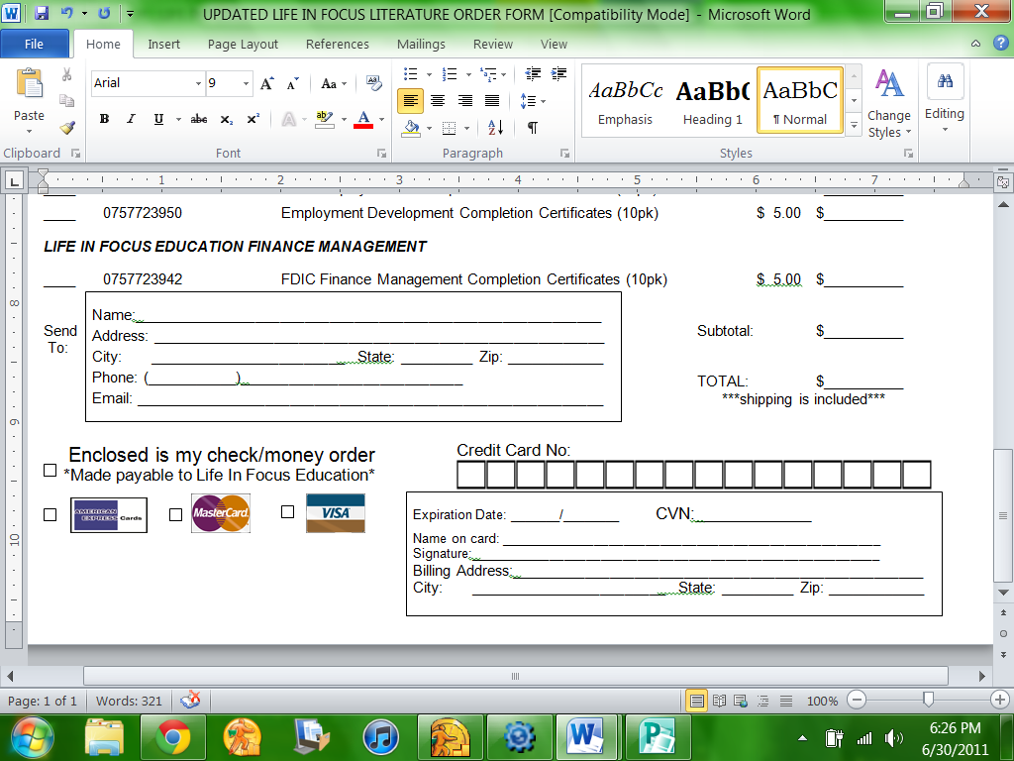

PERSONAL INFORMATION:

NAME:

EMAIL:

ADDRESS:

CITY:

STATE:

ZIPCODE:

DOB:

DAYTIME PHONE:

PLEASE PROVIDE INFORMATION IF FAITH-BASED:

PASTOR’S NAME:

CHURCH ADDRESS:

STATE:

CHURCH FAX:

CHURCH PHONE:

CHURCH NAME:

CITY:

ZIPCODE:

TRAINING INFORMATION:

Do you fully understand that it is necessary to be trained by a District or Regional Life In Focus Education Coordinator, or to have completed the Training Seminar via DVD?

Have you viewed the Training Seminar DVDs or attended a LIVE Seminar?

YES ____ NO ____

YES ____ NO ____

• PLEASE INITIAL TO VARIFY COMPLETION OF THE CORE TRAINING:

__________ (initial) LIFE IN FOCUS EDUCATION CORE TRAINING

• PLEASE CHECK THE FOLLOWING TRAINING CLASSES THAT YOU HAVE ATTENDED OR VIEWED VIA TRAINING DVDS:

 _____ **ALCOHOL/CHEMICAL TREATMENT SERIES (ACTS)

_____ ANGER MANAGEMENT

_____ EMPLOYMENT DEVELOPMENT

_____ PARENTING/MARRIAGE TRAINING

**NOTE**

If you are acquiring certification for the Drug Education (ACTS) program, it is

necessary to purchase & complete the ACTS Study guide & Workbook

DENOMINATION:

www.lifeinfocus.org

Life In Focus Education

Certification Application

Life In Focus Education, Inc.

5021 Curtis Clark Drive

Corpus Christi, TX 78411

361.992.7494 Phone/Fax

CHURCH EMAIL:

SIGNATURES:

THE FOLLOWING IS A POLICY REQUIREMENT:

In order to have your application processed, you MUST have your pastor’s signature below and he/she MUST have credentials with the United Pentecostal Church International. If your pastor does not have credentials with the United Pentecostal Church International, you must provide a written recommendation from a UPCI pastor or have that pastor sign this application. ______ YES, CREDENTIALS WITH THE UPCI

DATE:

APPLICANT’S SIGNATURE:

DATE:

PASTOR’S SIGNATURE:

CERTIFICATION FEES:

Life In Focus Education is a self-certifying agent. Each certification is independent of each other. Once you have completed the CORE Training, you need only to complete the specialized certification class(es). ID Badge is included in the certification cost. The ID badge that will list your multiple (if any) certifications.

 Specialized Certification Classes Available Price per certification

Anger Management Implementation _______$20.00

Employment Development _______$20.00

PARENTING/MARRIAGE TRAINING _______$20.00

ACTS (Drug Education) _______$25.00

• This completed and signed Life In Focus Education Training Application.

• A 2x2 inch photograph of yourself.

• Payment

Mail to Life In Focus

(address on first page)

*or*

Fax application (call in credit card information)

*or*

Email to: amberortegon@gmail.com

PLEASE SUBMIT THE FOLLOWING: